NETWORK EVIDENCE ACQUISITION (PCAP), SHA-256 HASHING, AND BLOCKCHAIN SIMULATION

Assignment: Network Evidence Acquisition, SHA-256 Hashing, and Blockchain Simulation


Student Identity
Name: Abdulaziz Bawadi
NIM: 23040700104
Course: Blockchain

UNIVERSITAS MUHAMMADIYAH JAKARTA
FAKULTAS TEKNIK
2026
1. Introduction
Digital evidence plays a critical role in digital forensics and network investigations. One of the main challenges in handling digital evidence is maintaining its integrity throughout the investigation process. Any modification to evidence may affect its validity and admissibility.
To address this issue, cryptographic hashing and blockchain technology can be used. Hashing provides a unique digital fingerprint for evidence, while blockchain ensures that evidence records remain tamper-resistant through chained blocks.
This project implements a simple blockchain system that stores metadata from PCAP network evidence files and validates their integrity using SHA-256 hashing.

2. Objectives
The objectives of this project are:
- To acquire network traffic evidence in PCAP format.
- To calculate SHA-256 hashes for each evidence file.
- To implement a simple blockchain for storing evidence metadata.
- To validate blockchain integrity.
- To demonstrate tampering detection through evidence modification.
- To understand the role of blockchain in maintaining chain of custody.

3. Network Evidence Acquisition
Network traffic evidence was generated and stored as PCAP files using Python and Scapy.
Five evidence files were created according to the assignment requirements:
File Name | Packet Count
PCAP01_23040700104.pcap | 30
PCAP02_23040700104.pcap | 50
PCAP03_23040700104.pcap | 70
PCAP04_23040700104.pcap | 90
PCAP05_23040700104.pcap | 100

Each file contains a different number of packets to simulate different network traffic scenarios.
4. SHA-256 Hash Calculation
SHA-256 was used to generate a unique fingerprint for every PCAP evidence file.
The hashing process provides:
- Evidence authenticity verification.
- Tampering detection.
- Digital identification of evidence.
For each evidence file, the following information was collected:
- File name
- Packet count
- File size
- SHA-256 hash value
Because SHA-256 is highly sensitive to data changes, even a one-byte modification produces a completely different hash value.
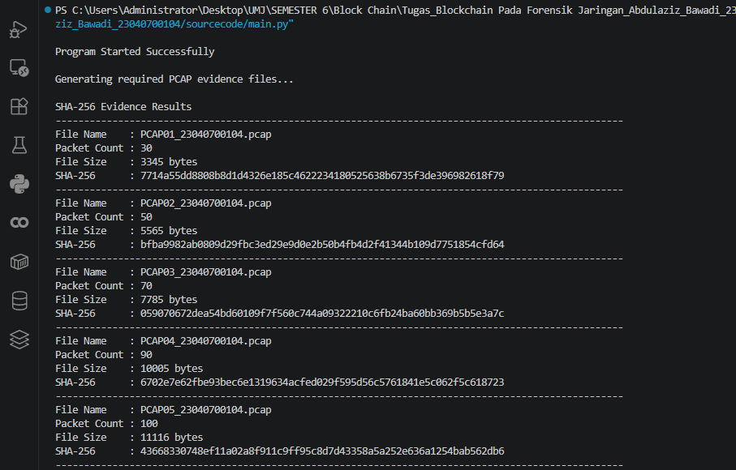
5. Blockchain Structure
The blockchain consists of:
- One Genesis Block
- Five Evidence Blocks
Each block contains:
- Index
- Timestamp
- Evidence File Name
- Packet Count
- Evidence SHA-256 Hash
- Previous Hash
- Block Hash
The Previous Hash field links every block to the preceding block, creating an immutable chain.
Block Hash values are generated from all block attributes using SHA-256.
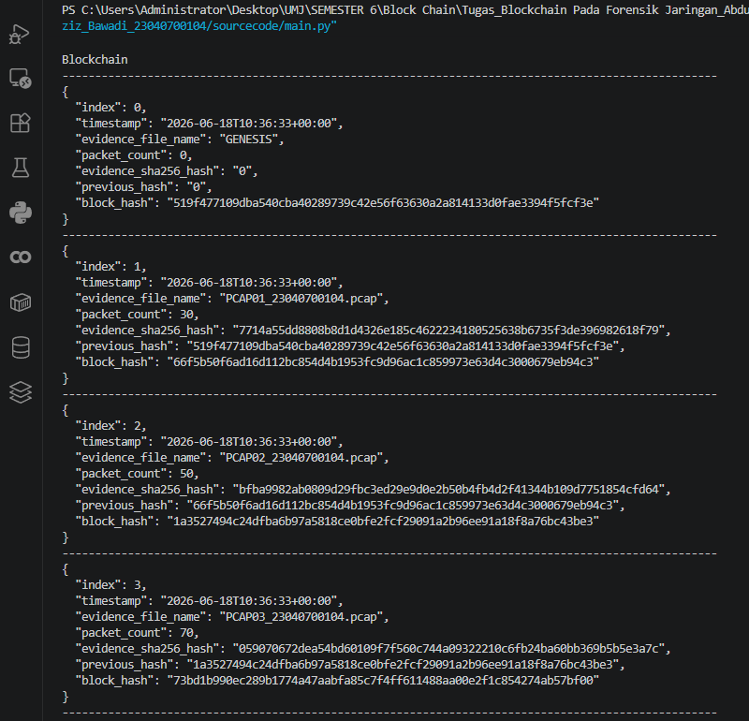
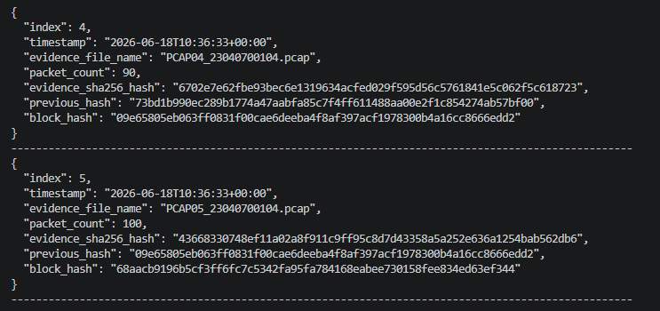
6. Blockchain Validation Mechanism
The blockchain validation process verifies:
- Previous Hash consistency.
- Block Hash correctness.
- Evidence Hash integrity.
The validation algorithm recalculates all hashes and compares them against stored values.
If all values match:
Blockchain Validation = VALID
If any mismatch is found:
Blockchain Validation = INVALID
This mechanism ensures that any modification to evidence can be immediately detected.

7. Merkle Tree Implementation
A Merkle Tree was implemented using the SHA-256 hashes of all evidence files.
Process:
- SHA-256 hashes are used as leaf nodes.
- Adjacent hashes are combined.
- New parent hashes are calculated.
- The process repeats until a single hash remains.
The final hash is called the Merkle Root.
Benefits:
- Efficient integrity verification.
- Reduced verification complexity.
- Commonly used in modern blockchain systems.
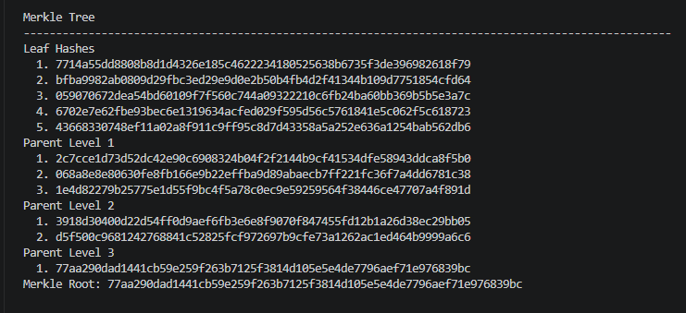
8. Tampering Simulation
A manual tampering test was performed.
Procedure:
- Blockchain was created and validated.
- One PCAP evidence file was manually modified.
- SHA-256 hash was recalculated.
- Blockchain validation was executed again.
Result:
Original evidence hash and modified evidence hash became different.
The blockchain successfully detected the modification and changed the validation status from VALID to INVALID.
This demonstrates the effectiveness of cryptographic hashing and blockchain-based integrity verification.

9. Results and Discussion
Before tampering:
- Blockchain Status: VALID
- All evidence hashes matched.
- All block hashes matched.
- Previous Hash links were correct.
After tampering:
- Evidence hash changed.
- Blockchain validation failed.
- Tampering was detected successfully.
The experiment demonstrates that blockchain can effectively preserve digital evidence integrity and support forensic investigations.

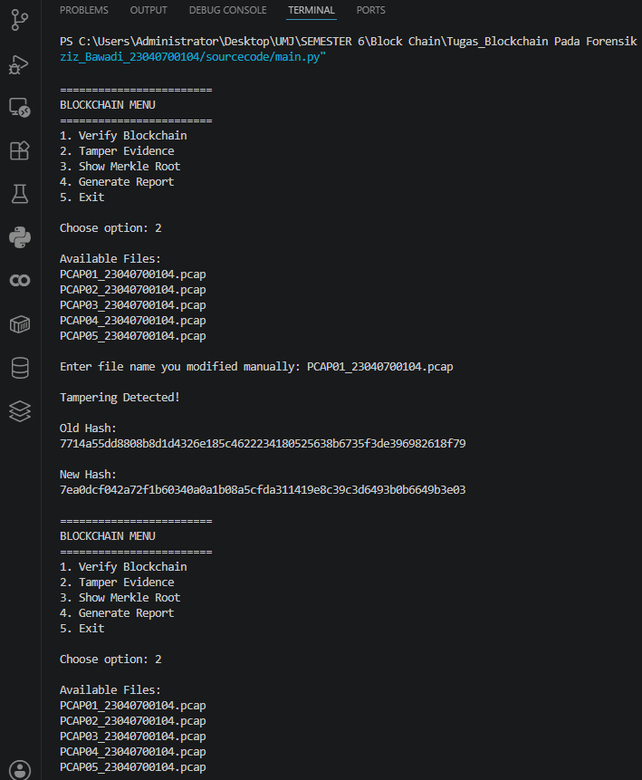

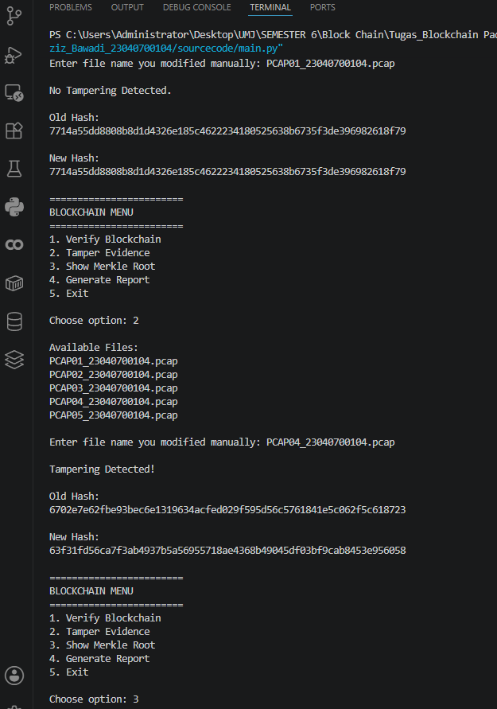
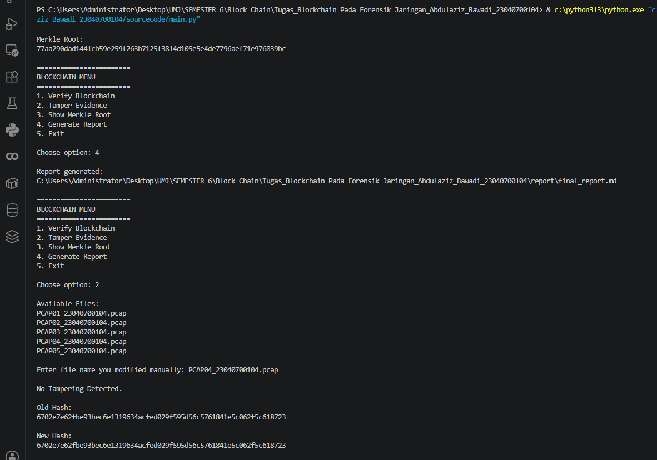

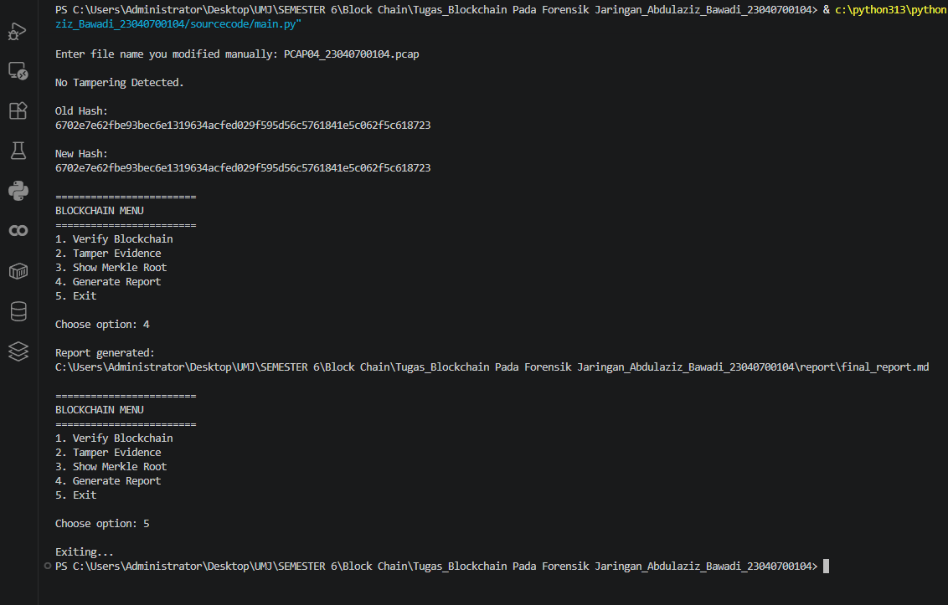

10. Conclusion
This project successfully implemented:
- Network evidence acquisition using PCAP files.
- SHA-256 hashing for digital evidence identification.
- A simple blockchain structure.
- Blockchain validation mechanisms.
- Merkle Tree construction.
- Manual tampering detection.
The results show that blockchain technology can significantly improve the integrity, traceability, and chain of custody of digital forensic evidence.
By combining SHA-256 hashing and blockchain, investigators can detect unauthorized modifications and maintain trustworthy evidence records throughout the forensic process.

References
Nakamoto, S. (2008). Bitcoin: A Peer-to-Peer Electronic Cash System.
Stallings, W. Cryptography and Network Security.
NIST Secure Hash Standard (SHA-256).
Python Documentation.
Scapy Documentation.

Video Presentasion
https://drive.google.com/file/d/1lWGD5dvYGGbTpKt2FediHWszZfyhH0bA/view?usp=sharing

